Project Synopsis: Student Performance Prediction System
CODE/ IMPLEMENTATION
import pandas as pd
import numpy as np
import matplotlib.pyplot as plt
import seaborn as sns
from sklearn.model_selection import train_test_split
from sklearn.preprocessing import LabelEncoder
from sklearn.preprocessing import StandardScaler
from sklearn.linear_model import LogisticRegression
from sklearn.tree import DecisionTreeClassifier
from sklearn.naive_bayes import GaussianNB
from sklearn.svm import SVC
from sklearn.ensemble import RandomForestClassifier
from sklearn.metrics import accuracy_score
from sklearn.metrics import precision_score
from sklearn.metrics import recall_score
from sklearn.metrics import f1_score
from sklearn.metrics import confusion_matrix
from sklearn.metrics import classification_report
# =====================================================
# STEP 1 : CREATE DATAFRAME DATASET
# =====================================================
print("\n========== STUDENT PERFORMANCE PREDICTION SYSTEM ==========")
# Creating dataset directly inside code
data = pd.DataFrame({
'Student_ID': [
101, 102, 103, 104, 105,
106, 107, 108, 109, 110
],
'Study_Hours': [
4, 1, 5, 2, 6,
3, 7, 2, 5, 4
],
'Attendance': [
85, 45, 90, 60, 95,
70, 98, 55, 88, 80
],
'Previous_Marks': [
70, 40, 88, 50, 93,
65, 96, 48, 84, 75
],
'Assignments': [
75, 35, 92, 55, 90,
68, 95, 50, 86, 72
],
'Internal_Marks': [
72, 38, 91, 58, 94,
66, 97, 52, 85, 74
],
'Final_Result': [
'Pass', 'Fail', 'Pass', 'Fail', 'Pass',
'Pass', 'Pass', 'Fail', 'Pass', 'Pass'
]
})
print("\nDataset Created Successfully!")
# Display dataset
print("\n========== DATASET PREVIEW ==========")
print(data)
# =====================================================
# STEP 2 : DATA PREPROCESSING
# =====================================================
print("\n========== DATA PREPROCESSING ==========")
# Check missing values
print("\nMissing Values:")
print(data.isnull().sum())
# Encode Final_Result
# Pass = 1, Fail = 0
label_encoder = LabelEncoder()
data['Final_Result'] = label_encoder.fit_transform(
data['Final_Result']
)
print("\nEncoded Final_Result:")
print(data['Final_Result'])
# =====================================================
# STEP 3 : EXPLORATORY DATA ANALYSIS (EDA)
# =====================================================
print("\n========== EXPLORATORY DATA ANALYSIS ==========")
# Study Hours vs Previous Marks
plt.figure(figsize=(8,5))
sns.scatterplot(
x='Study_Hours',
y='Previous_Marks',
hue='Final_Result',
data=data
)
plt.title('Study Hours vs Previous Marks')
plt.show()
# Attendance vs Final Result
plt.figure(figsize=(8,5))
sns.boxplot(
x='Final_Result',
y='Attendance',
data=data
)
plt.title('Attendance vs Final Result')
plt.show()
# Correlation Heatmap
plt.figure(figsize=(10,6))
sns.heatmap(
data.corr(),
annot=True,
cmap='coolwarm'
)
plt.title('Feature Correlation Heatmap')
plt.show()
# =====================================================
# STEP 4 : FEATURE SELECTION
# =====================================================
print("\n========== FEATURE SELECTION ==========")
X = data[[
'Study_Hours',
'Attendance',
'Previous_Marks',
'Assignments',
'Internal_Marks'
]]
y = data['Final_Result']
print("\nSelected Features:")
print(X)
# =====================================================
# STEP 5 : FEATURE SCALING
# =====================================================
scaler = StandardScaler()
X_scaled = scaler.fit_transform(X)
# =====================================================
# STEP 6 : TRAIN TEST SPLIT
# =====================================================
X_train, X_test, y_train, y_test = train_test_split(
X_scaled,
y,
test_size=0.20,
random_state=42
)
print("\nTraining Data Size:", len(X_train))
print("Testing Data Size :", len(X_test))
# =====================================================
# STEP 7 : MODEL TRAINING
# =====================================================
print("\n========== MODEL TRAINING ==========")
models = {
'Logistic Regression': LogisticRegression(),
'Decision Tree': DecisionTreeClassifier(),
'Naive Bayes': GaussianNB(),
'Support Vector Machine': SVC(),
'Random Forest': RandomForestClassifier()
}
model_results = {}
for name, model in models.items():
print(f"\nTraining {name}...")
# Train model
model.fit(X_train, y_train)
# Predict
y_pred = model.predict(X_test)
# Evaluation Metrics
accuracy = accuracy_score(y_test, y_pred)
precision = precision_score(y_test, y_pred)
recall = recall_score(y_test, y_pred)
f1 = f1_score(y_test, y_pred)
model_results[name] = accuracy
print("\nAccuracy :", round(accuracy * 100, 2), "%")
print("Precision:", round(precision * 100, 2), "%")
print("Recall :", round(recall * 100, 2), "%")
print("F1 Score :", round(f1 * 100, 2), "%")
# Confusion Matrix
cm = confusion_matrix(y_test, y_pred)
print("\nConfusion Matrix:")
print(cm)
print("\nClassification Report:")
print(classification_report(y_test, y_pred))
# =====================================================
# STEP 8 : BEST MODEL SELECTION
# =====================================================
best_model_name = max(model_results, key=model_results.get)
print("\n========== BEST MODEL ==========")
print("Best Model:", best_model_name)
best_model = models[best_model_name]
# =====================================================
# STEP 9 : PREDICTION SYSTEM
# =====================================================
print("\n========== STUDENT PERFORMANCE PREDICTION ==========")
# User Input
study_hours = float(input("Enter Study Hours: "))
attendance = float(input("Enter Attendance Percentage: "))
previous_marks = float(input("Enter Previous Marks: "))
assignments = float(input("Enter Assignment Marks: "))
internal_marks = float(input("Enter Internal Marks: "))
# Create input array
new_student = np.array([[
study_hours,
attendance,
previous_marks,
assignments,
internal_marks
]])
# Scale input
new_student_scaled = scaler.transform(new_student)
# Predict
prediction = best_model.predict(new_student_scaled)
# Display Result
if prediction[0] == 1:
print("\nPrediction Result: PASS")
else:
print("\nPrediction Result: FAIL")
# =====================================================
# STEP 10 : IDENTIFY AT-RISK STUDENTS
# =====================================================
print("\n========== AT-RISK STUDENTS ==========")
all_predictions = best_model.predict(X_scaled)
data['Predicted_Result'] = all_predictions
risk_students = data[data['Predicted_Result'] == 0]
print(risk_students[
['Student_ID', 'Attendance', 'Previous_Marks']
])
# =====================================================
# STEP 11 : VISUALIZATION
# =====================================================
# Model Accuracy Comparison
plt.figure(figsize=(10,5))
model_names = list(model_results.keys())
accuracies = list(model_results.values())
plt.bar(model_names, accuracies)
plt.xlabel('Machine Learning Models')
plt.ylabel('Accuracy')
plt.title('Model Accuracy Comparison')
plt.xticks(rotation=10)
plt.show()
# Pass/Fail Pie Chart
plt.figure(figsize=(6,6))
result_labels = ['Fail', 'Pass']
result_counts = data['Final_Result'].value_counts()
plt.pie(
result_counts,
labels=result_labels,
autopct='%1.1f%%'
)
plt.title('Student Result Distribution')
plt.show()
# =====================================================
# STEP 12 : SAVE OUTPUT
# =====================================================
output_file = 'student_prediction_output.xlsx'
data.to_excel(output_file, index=False)
print("\nPrediction results saved successfully!")
print("Output File:", output_file)
print("\n========== PROJECT COMPLETED SUCCESSFULLY ==========")

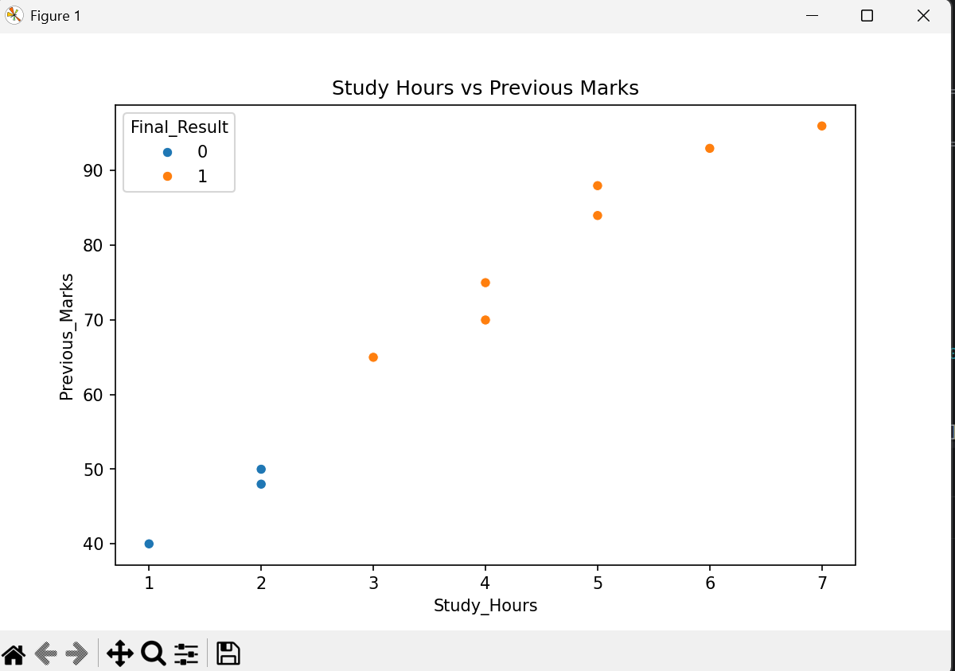

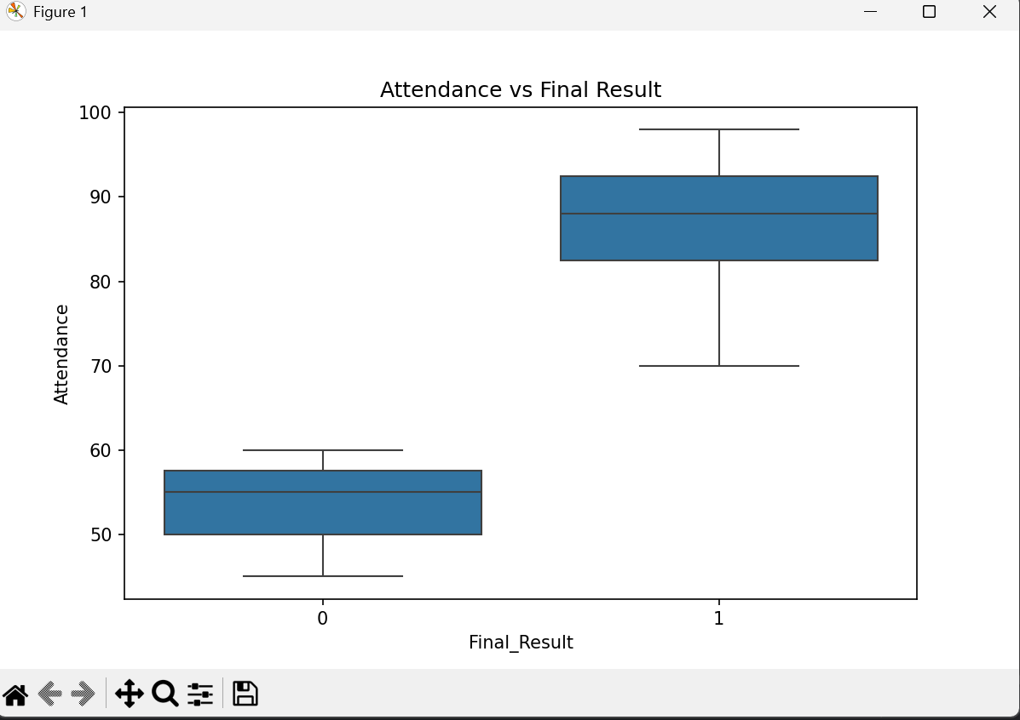

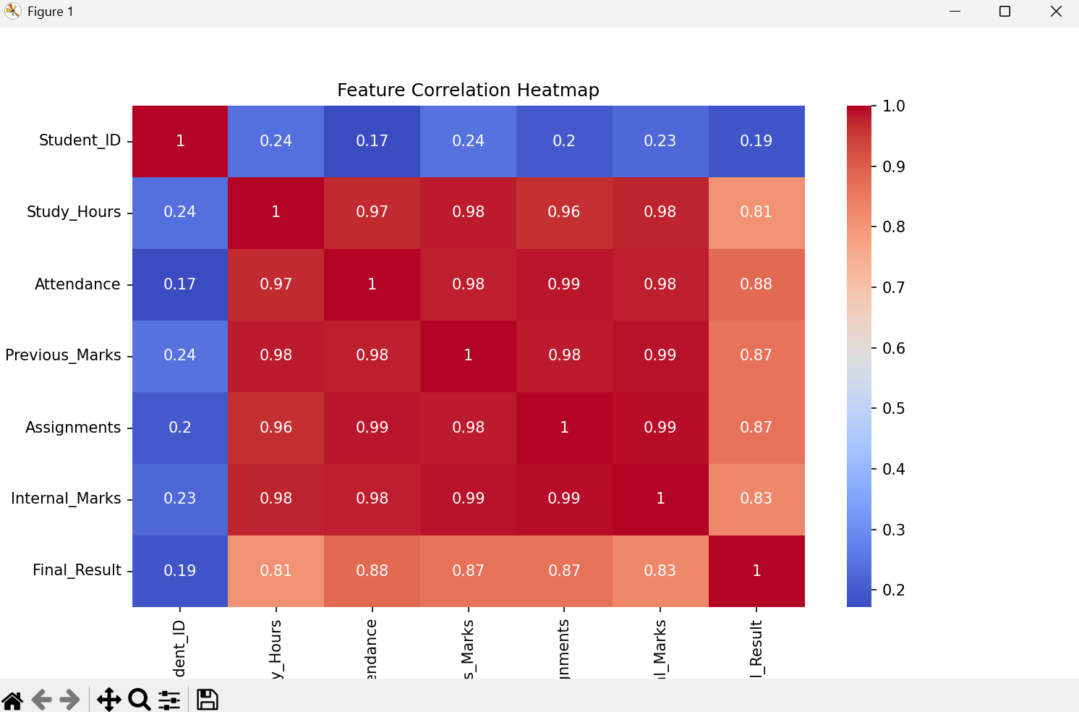
========= STUDENT PERFORMANCE PREDICTION ==========
Enter Study Hours: 5
Enter Attendance Percentage: 89
Enter Previous Marks: 78
Enter Assignment Marks: 77
Enter Internal Marks: 90
Prediction Result: PASS 